**EXP. NO: 10**

**RIPPLE CARRY ADDER**

***NAME: RAHUL GOEL***

***Reg No.: RA1911030010094***

***DATE: 14/09/2020***

**Aim:**

To design and implement a ripple carry adder

**Truth Table:**

|  |  |  |  |  |  |  |  |  |  |  |  |  |
| --- | --- | --- | --- | --- | --- | --- | --- | --- | --- | --- | --- | --- |
| **A1** | **A2** | **A3** | **A4** | **B4** | **B3** | **B2** | **B1** | **S4** | **S3** | **S2** | **S1** | **CARRY** |
| **0** | **0** | **0** | **0** | **0** | **0** | **0** | **0** | **0** | **0** | **0** | **0** | **0** |
| **0** | **1** | **0** | **0** | **0** | **1** | **0** | **0** | **1** | **0** | **0** | **0** | **0** |
| **1** | **0** | **0** | **0** | **1** | **0** | **0** | **0** | **0** | **0** | **0** | **0** | **1** |
| **1** | **0** | **1** | **0** | **1** | **0** | **1** | **0** | **0** | **1** | **0** | **0** | **1** |
| **1** | **1** | **0** | **0** | **1** | **1** | **0** | **0** | **1** | **0** | **0** | **0** | **1** |
| **1** | **1** | **1** | **0** | **1** | **1** | **1** | **0** | **1** | **1** | **0** | **0** | **1** |
| **1** | **1** | **1** | **1** | **1** | **1** | **1** | **1** | **1** | **1** | **1** | **0** | **1** |

**Circuit Diagram:**

**Observation:**

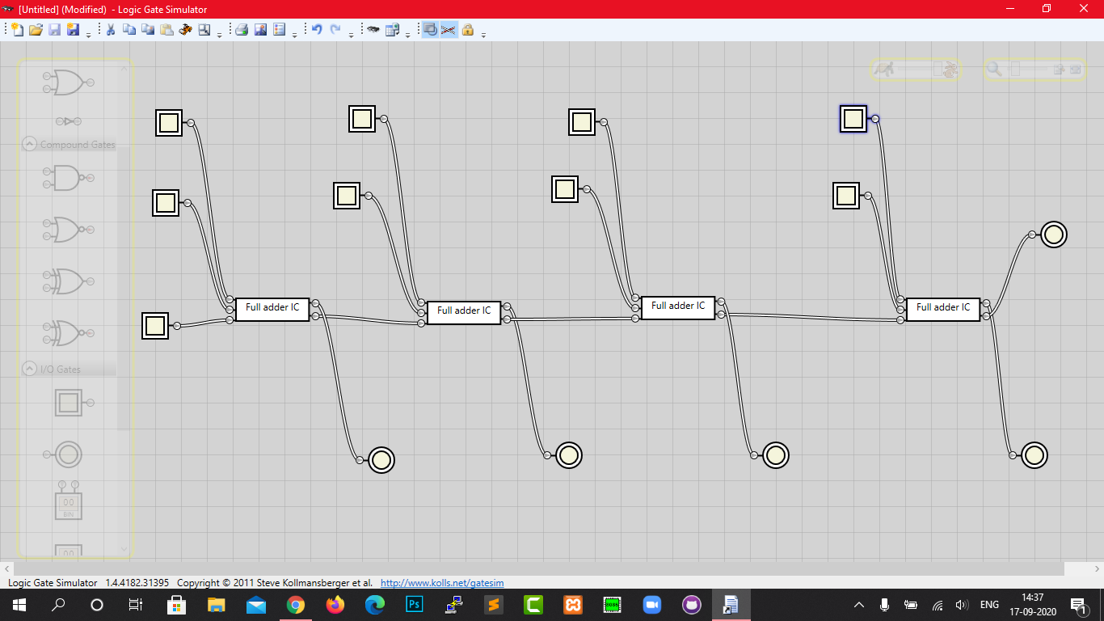

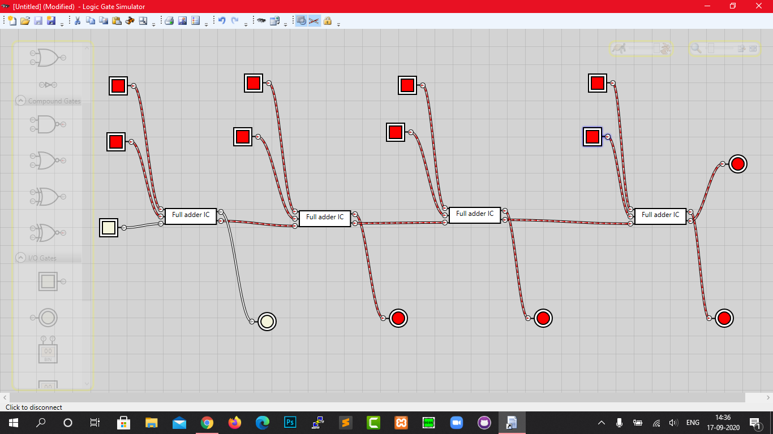

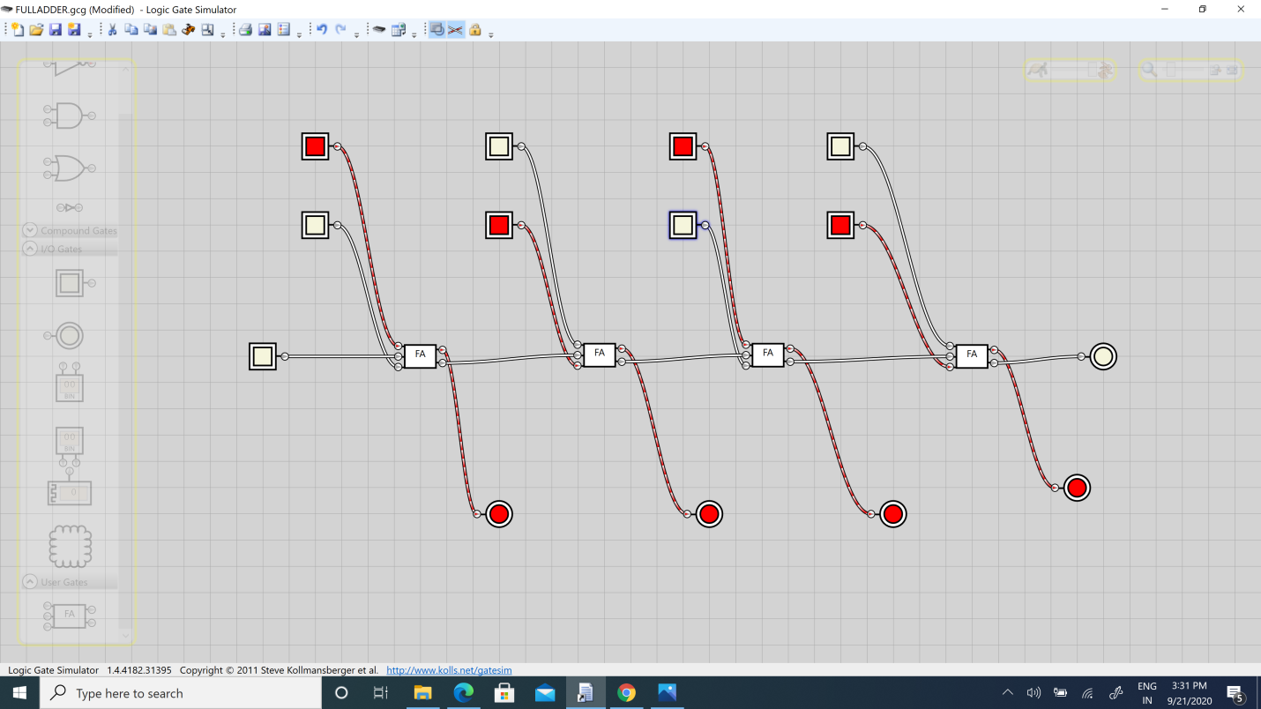

***Result:***

***Hence, ripple carry adder was constructed in the simulator & its characteristics were studied.***